AZURE ASSIGNMENT 2 – STORAGE ACCOUNTS

1. CREATING AZURE STANDARD STORAGE ACCOUNT WITHOUT HIERARCHICAL NAMESPACE  
     
   A screenshot of a computer

   Description automatically generated

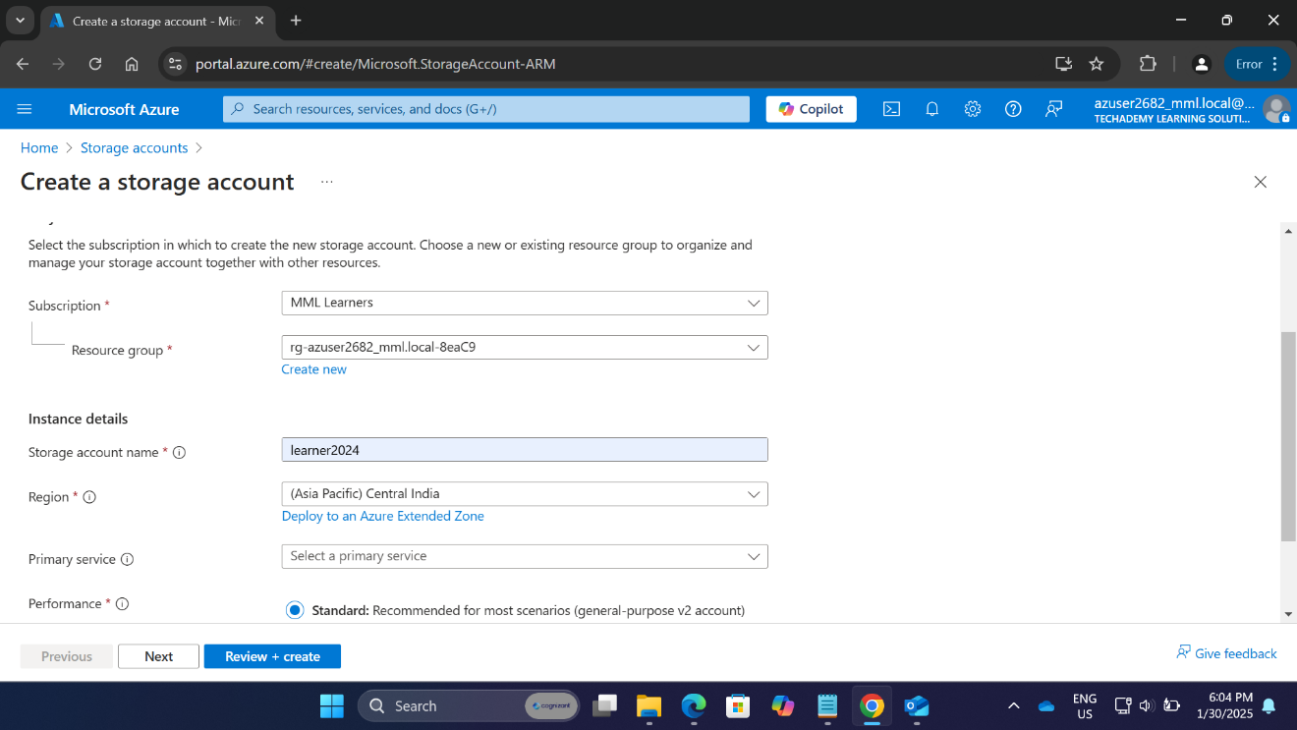

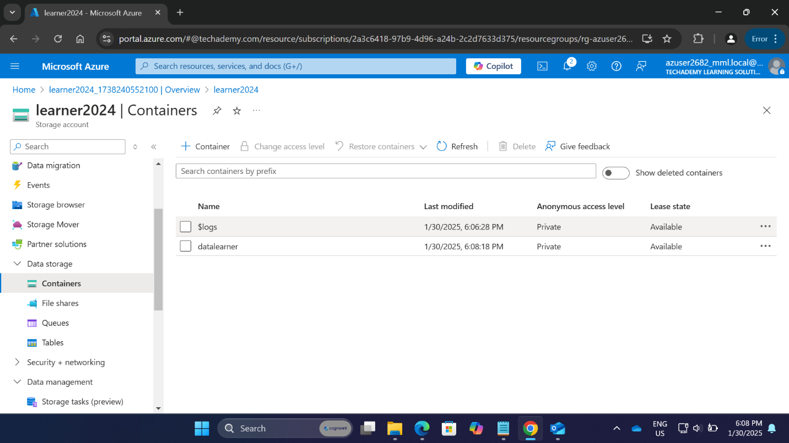

1. CREATING AZURE STANDARD STORAGE ACCOUNT WITH HIERARCHICAL NAMESPACE

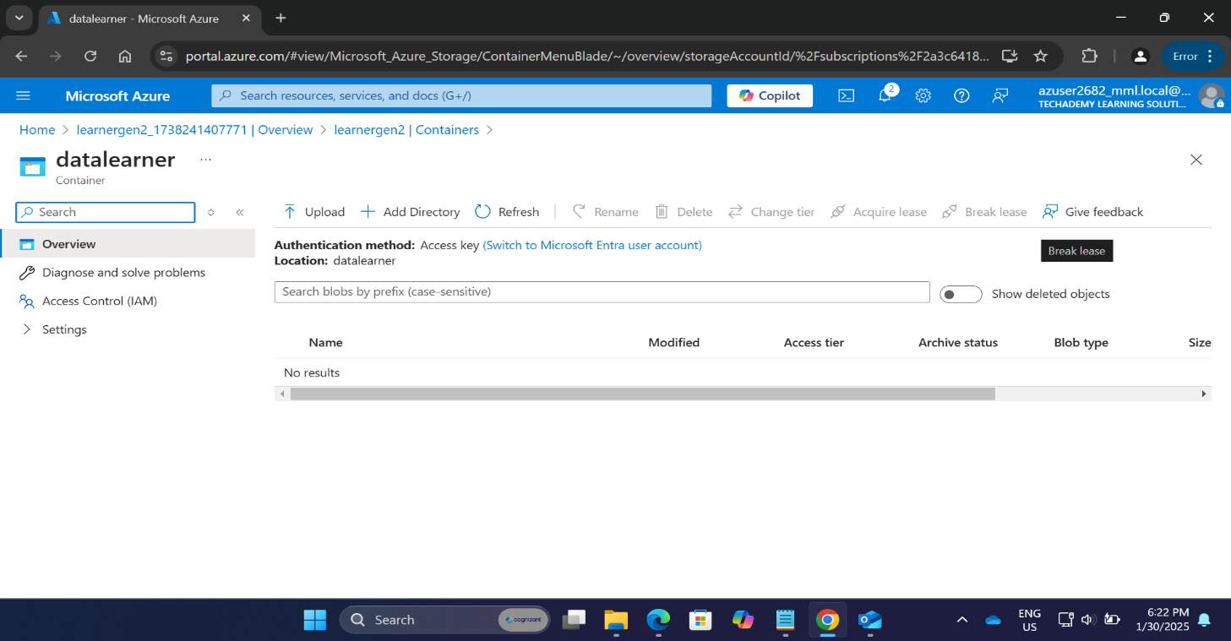

1. CREATING AZURE PREMIUM BLOCK BLOBS STORAGE ACCOUNT WITHOUT HIERARCHICAL NAMESPACE

1. CREATING AZURE PREMIUM BLOCK BLOBS STORAGE ACCOUNT WITH HIERARCHICAL NAMESPACE

1. CREATING AZURE PREMIUM FILE SHARES STORAGE ACCOUNT

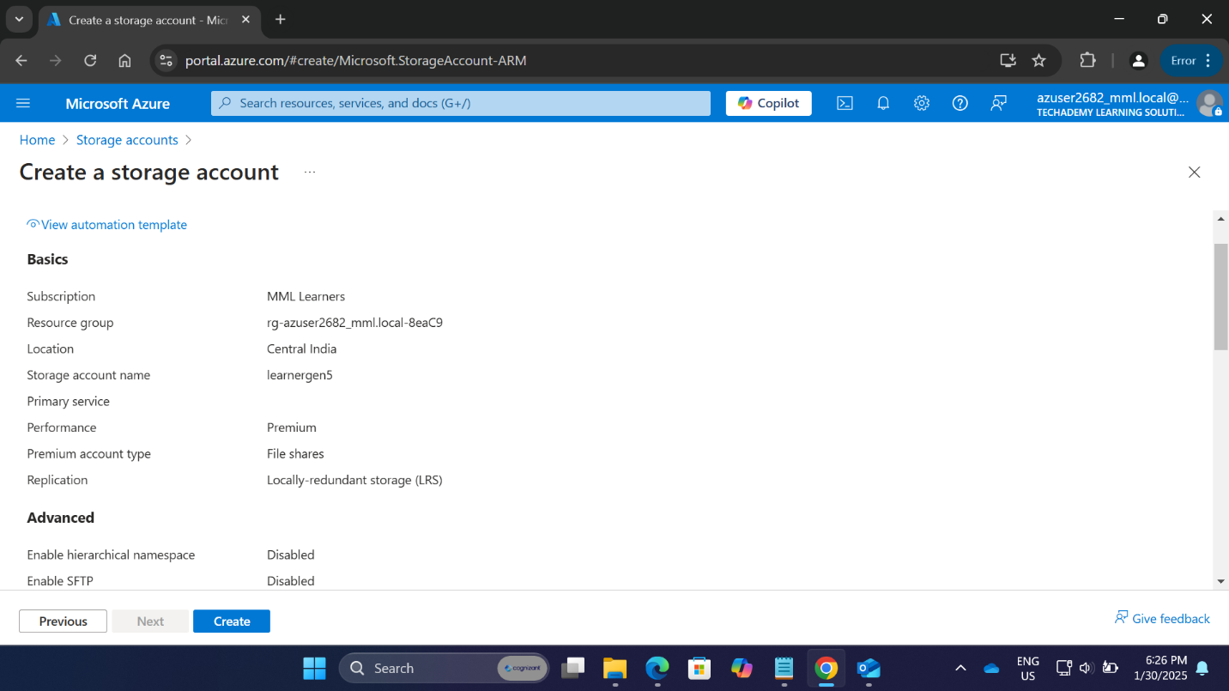

1. CREATING AZURE PREMIUM PAGE BLOBS STORAGE

